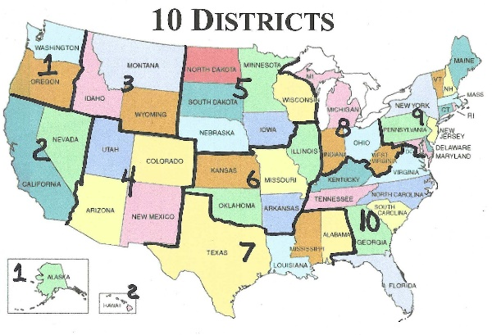

* **District Coordinators** – are the “Face of NLA to County Committees of Safety Committee of Correspondence for the states within their district. We have divided the Nation into 10 Districts. District Coordinators are responsible for:

● Develop a relationship with County COS, assisting and encouraging them to build their COS upon education provided by NLA and providing a list (name, county, and phone) of all NLA members in their state. All communications must be by phone not email. Email is only for sending supporting information after a phone call and to remind the County Committees of an up-coming meeting.

● Districts with more than 5 states need a min of 2 District Coordinators. There is an average of 60 counties per state. Therefore, each Coordinator is responsible for coordinating and assisting about 300 counties (60x5).

● Coordinators are to maintain a log using MS Word. Record bullet points and/or detailed info during each phone conversation. Create a folder for each state and sub folders for each county. Do not be long winded the purpose of this info will help you to remember who you are talking to and where to pick up on your next conversation. It also will assist another coordinator should you have to retire your position.

● Maintain a spread sheet of all active County COS. Use a tab in excel for each state. (*Cut and paste the counties for each state provided by NLA*) Record the COS organizer for each county. Name – Phone – E-mail – Number of Members – Date Established – Connected to Sheriff.

● Report to the “National Coordinator” all County COS’s progress on the 4th Monday of the month.

● We will have a meeting to discuss the aforesaid details and create a uniform procedure.

* **NLA Representatives** to help find and schedule interviews for Gerard and John, radio, pod-casts, etc.
* **NLA Representatives** to help find financial supporters and recommend fundraising ideas
* **Researchers**
* **Paralegals**
* **Welcoming Committee** – make contact with our members to welcome them and assist them in education and encourage them to join their County COS, connect them with their District Coordinator to help them connect
* **Educators** –
* **Admin group** –
* **Outreach group** –
* **Technical Assistance** –
* **Social Media group** – twitter, face-book, truth-social, etc.
* **Fundraising Group** -

Visit > [www.nationallibertyalliance.org/district-coordinators-page](http://www.nationallibertyalliance.org/district-coordinators-page) for more details.

Needs Desiree

=============================================

<https://acrobat.adobe.com/id/urn:aaid:sc:VA6C2:a020fd48-9e4a-4d48-9073-095e87a3c944>

Chance-Steven

csterrilltrust@gmail.com 765-419-8650

That is chance

==============================================

You will see why I made the urgent suggestion for you to do an audio cast with SG Anon to get him to acknowledge the committees of safety to his followers, as the answer to all their questions he was answering his way. I am positive that it would elevate awareness and involvement in the committees of safety. You're going to wish you could have interjected in this audio cast. <https://rumble.com/v2e3h3u-sg-anon-situation-update-what-can-patriots-do.html>

SG Anon Situation Update: "We Should Take The Fight To Them"

https://rumble.com

7. Youtube Interviews!! I want to start scheduling!! I don't like dragging my feet!! I already sent you an email about an hour ago or so.

Email: mailitii@yahoo.com Screen Name on NLA. (Uselessness Knowledge) I am a premium member and have been for sometime!

Name on YouTube Uselessness Knowledge Sincerely, Anthony Johansen 3-18-23

==============================================

<http://www.miraclesingodwetrust.com/>

Brian's cell # is 419-371-4688. facebook@livetruthradio.com and livetruthradio.com. I hope to hear John on Brian's show. Thank you, Larry Betts